EVIDENCE IN SOCIAL MEDIA EXISTENCE

SHAWN NGALA

**LINKEDIN**

Username Nakurutoh

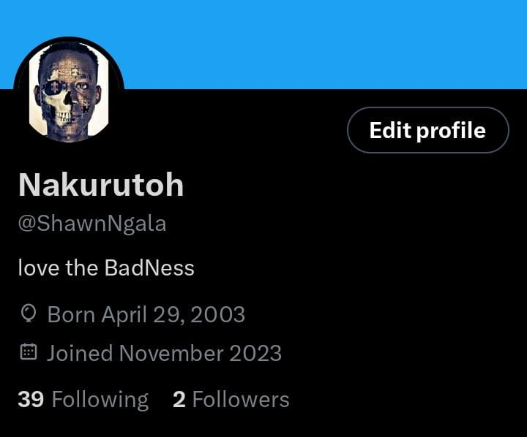

**INSTAGRAM**

Username:king_nakuruto

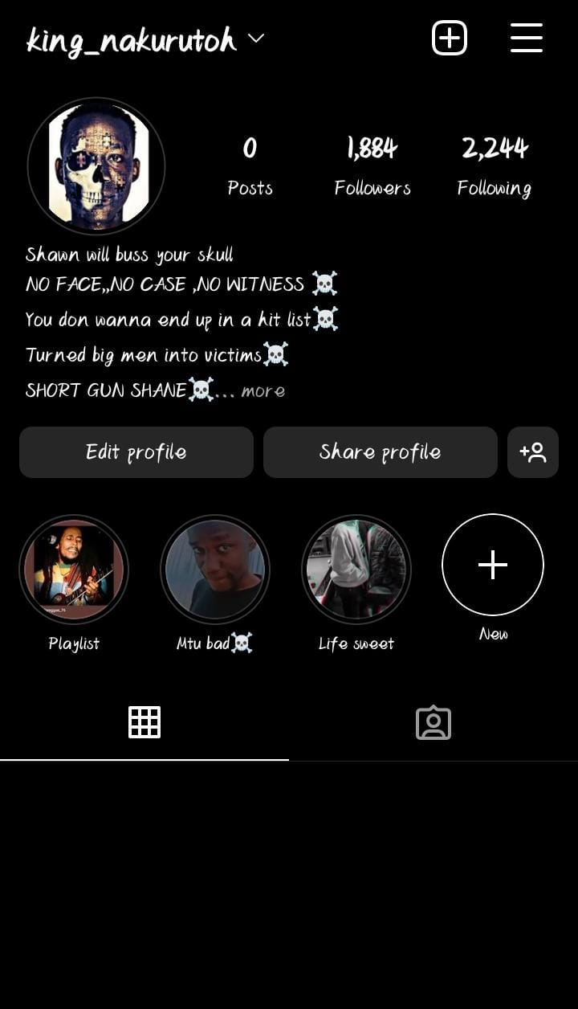

**FACEBBOK**

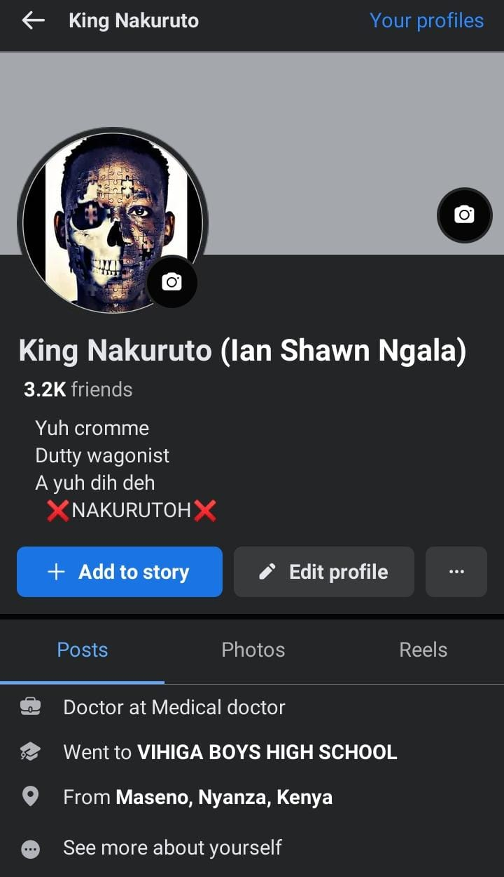

**WHATSAPP**

